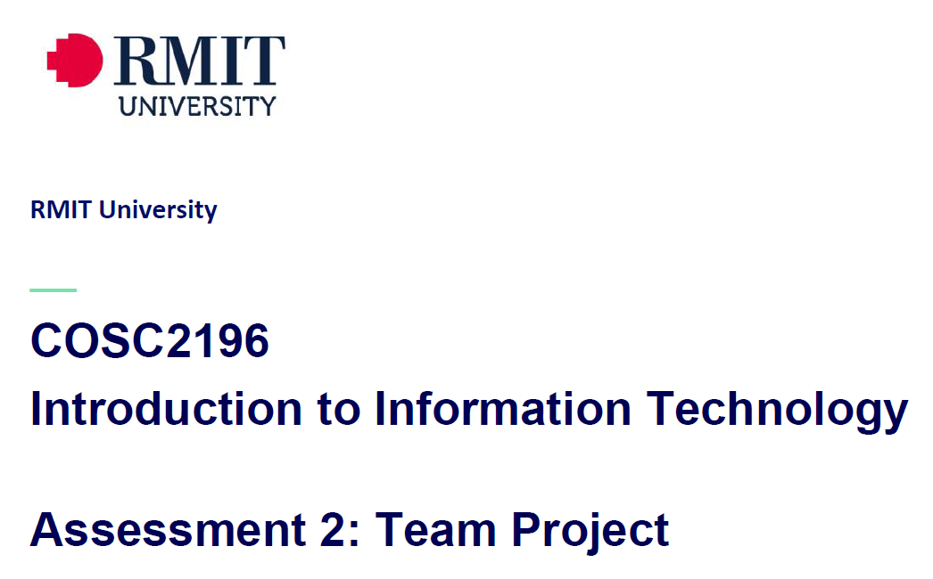
Team_Name_404 MEETING
Venue: Online via MS Teams
Date: 29/4/21

Minutes

Meeting Opened: (8.20pm)
Attendance: Paul Eccarius, Rebecca Watson, Martin Lee, Nour Zeroual
Apologies: none.
- Housekeeping/feedback on group process from A2:
- What is the best way to make use of MS Teams? (Bec) – we will just make 4 channels on teams this time to avoid breaking it up too much – A3, A5, General and Meetings.
- Has everyone had a chance to read through the Assignment/s?

- Appoint a Team Leader for A3/5? We will continue with the system of sharing the load as in A2.

ASSIGNMENT 3: Our IT Project (overall weighting 40%)

- Team Profile – 5%
- one page document per person, as per the team name/personal information/group processes/career plans. We each do our own two thirds of a page for this section. One person will make sure they all fit together and look seamless. Address group processes and comparing career plans.

- Tools – 5%
- Each group member needs to go into Github and fork it ourselves? May need some more direction on how to best make version 2.0 of our original website from A2. Lets look at this and figure out how it works by the next meeting.

- Project Plan/Description – 50%

- Overview:
- Detailed Description:
Aims
Plans & Progress
Roles
Scope and Limits
Tools & Technologies
Testing
Timeframe | What are the generic steps for building an app – research | Bec
Risks | fake profiles and catfishing
Group Processes & Communications

- Skills and Jobs – 15%

- Feedback – 7.5%

- Group Reflection – 7.5%
- Presentation – 10%

Assignment 5: Presentation (overall weighting 20%)

- Draft script + storyboard is due Sunday of Week 10
- Paul is going to have a look at putting the storyboard and a script over the long weekend.
- Specifics as per rubric:
Identification/Description
Need/Want/Users/Market
Innovation
Mechanics/Design
Length
Quality

- Additional points for discussion?
- A2 Contribution form/email from Umera: Bec to submit what is on there tomorrow and follow instructions as per Umera’s email.

Next meeting date: Wednesday 8pm 5/5/21
Meeting closed: 9.23pm

Actions Register

Meeting Date | Action | Who to action | Completed Y/N | Update at meeting | Further action
29/4/21 | Team Profile – each make 2/3s of a page as per spec.  Group processes and career plans/contrast to be done as an update on reflection/career work from A2. | Paul  Bec  Nour  Martin |  | 5/5/21
29/4/21 | Tools (GitHub) – find out best process for ‘forking’/ making version 2.0 of A2. May need to check forums or ask Umera/Anthony. | Team |  | 5/5/21
29/4/21 | Timeframe – research generic steps/timelines for building apps | Bec |  | 5/5/21
29/4/21 | A5 draft script + storyboard – due end of week 10. Paul to outline/mock up. | Paul |  | 5/5/21
29/4/21 | A2 Contribution – send what we have tomorrow (due date). Follow steps given via email from Umera if everyone hasn’t signed. | Bec

